**ERROR DETECTION AND HANDLING**

**1. WAP to read atleast 2 designation strings from the user. Using assert validate**

**i. Count of received designation strings**

**ii. Value of each string as one of {“E2”, “E3”, “E4”}**

**Failure of any of tested condition in i) or ii) should terminate program. On success should display the received valid designations**

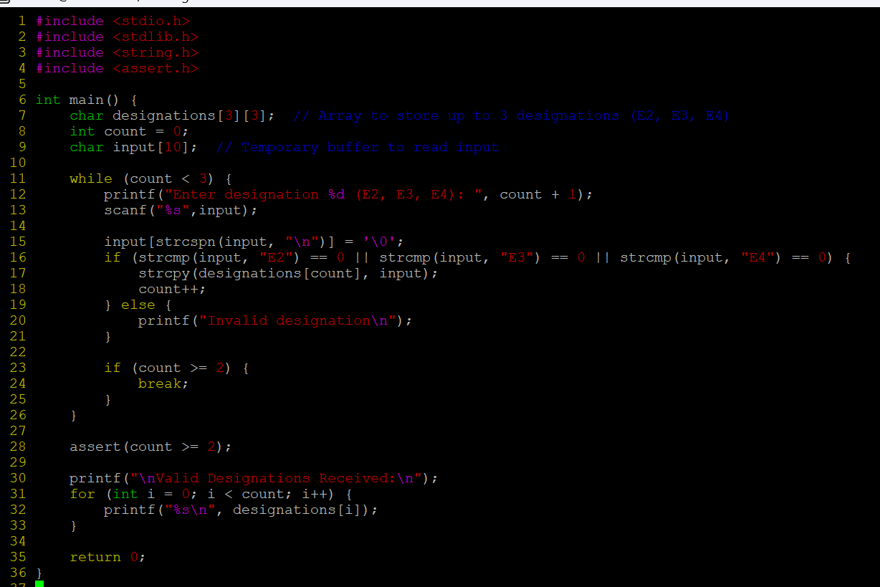

**OUTPUT:**

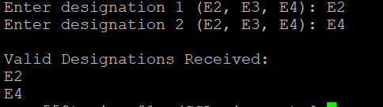

**2. Refer the code below. Modify code to use assert instead of if else. Add main and invoke function() and test it**

**void function(int x)**

**{**

**float fx;**

**if (x==0)**

**{**

**printf("Division by Zero is not allowed");**

**fprintf(stderr, "Division by zero! Exiting...\n");**

**exit(EXIT_FAILURE);**

**}**

**else**

**{**

**fx = 10 / x;**

**printf("f(x) is: %.5f", fx);**

**}**

**}**

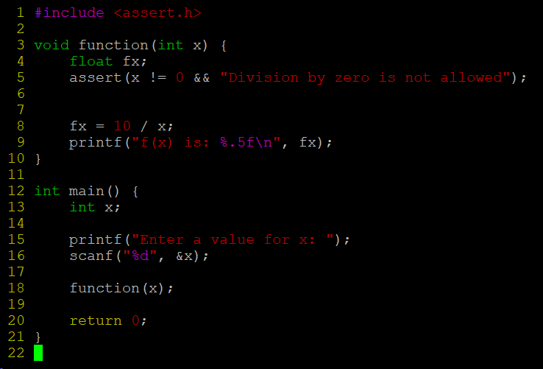

**OUTPUT:**

